## 3. Software Technology Explanation

### 3.1 Technical Details

#### 3.1.1 Overview

The system adopts the separate structure of front-end and back-end. Each front-end and back-end runs independently, and communicates through RESTful API during the period, which is conducive to parallel front-end and back-end development and improve efficiency.

#### 3.1.2 TypeScript, Python (programming language)

TypeScript is a free and open source programming language developed by Microsoft. It is a superset of JavaScript and essentially adds optional static types and class-based object-oriented programming to the language. TypeScript extends the syntax of JavaScript, so any existing JavaScript program can work under TypeScript without change. TypeScript is designed for the development of large applications, and it generates JavaScript at compile time to ensure compatibility. And it also supports adding header files with type information to existing JavaScript libraries, extending its benefits to popular libraries such as jQuery, MongoDB, Node.js and D3.js.

Python is an object-oriented interpretive computer programming language. Python is pure free software and it’s source code and interpreter CPython follow the GPL (GNU General Public License) protocol. Python's grammar is concise and clear, and one of its features is to force the use of white space as sentence indentation. Python has rich and powerful libraries, and can easily link various modules (especially C/C++) produced in other languages. Version 3.0 of Python is often called Python 3000, or Py3k for short. Compared with the earlier version of Python，Py3k is a larger upgrade. Python 3.0 was not designed for downward compatibility in order to avoid excessive burdens.

#### 3.1.3 Visual Studio Code、WebStorm、PyCharm（IDE）

Visual Studio Code is a cross-platform source code editor running on Mac OS X, Windows and Linux for writing modern Web and cloud applications. Visual Studio Code provides developers with built-in support for a variety of programming languages, as well as rich code completion and navigation capabilities for these languages. JavaScript, TypeScript, Node. JS and ASP. NET 5 developers will also get additional toolsets. The editor also integrates all the features that a modern editor should have, including syntax hight lighting, customizable keyboard bindings, bracket matching and snippets.

WebStorm is a powerful HTML5/JavaScript Web front-end development tool owned by Jetbrains. At present, JS developers in China have been praised as "the magic weapon of Web front-end development", "the most powerful HTML5 editor", "the most intelligent JavaScript IDE" and so on. Homologous to IntelliJ IDEA, it inherits the powerful JS function of IntelliJ IDEA.

PyCharm is a Python IDE with a set of tools that can help users improve their efficiency when developing in Python language, such as debugging, grammar highlighting, project management, code jumping, intelligent hints, automatic completion, unit testing, version control. In addition, the IDE provides some advanced functions to support professional Web development within the framework of flask.

#### 3.1.4 Vue (Front View Framework)

Vue.js is a progressive framework for building user interfaces. Unlike other heavyweight frameworks, Vue uses a bottom-up incremental design. It’s core library focuses only on the view layer and is very easy to learn and integrate with other libraries or existing projects. On the other hand, Vue has complete capability of driving complex single-page applications, which uses single file components and libraries supported by Vue ecosystems.

The goal of Vue.js is to implement data binding and composite view components for response through as simple an API as possible.

#### 3.1.5 MySQL (database)

MySQL is a relational database management system, developed by Swedish MySQL AB Company, and currently belongs to Oracle's products. MySQL is one of the most popular relational database management systems. In WEB applications, MySQL is one of the best RDBMS (Relational Database Management System) applications. MySQL is a relational database management system, which stores data in different tables instead of all data in a large warehouse, thus increasing speed and flexibility. The SQL language used by MySQL is the most commonly used standardized language for accessing databases. MySQL software adopts a dual authorization policy, which is divided into community version and commercial version. Because of its small size, fast speed and low overall cost of ownership, especially open source, MySQL is generally chosen as the website database for the development of small and medium-sized websites. Because of its excellent performance in community edition, it can form a good development environment with PHP and Apache.

#### 3.1.6 Swagger

Swagger is a normative and complete framework for generating, describing, invoking and visualizing RESTful-style Web services. The overall goal is to update the client and file system as servers at the same speed. File methods, parameters and models are tightly integrated into server-side code, allowing APIs to keep synchronization at all times. Swagger is a general API description specification that is independent of programming language. It can run through the whole API ecosystem, such as API design, API documentation, testing and deployment.

#### 3.1.7 Git (Version Control Tool)

Git is an open source distributed version control system, which can effectively and quickly handle version management from very small to very large projects. Git is an open source version control software developed by Linus Torvalds to help manage Linux kernel development.

#### 3.1.8 ElementUI (UI Component Library)

ElementUI is a desktop component library based on Vue 2.0 for developers, designers and product managers. It has the characteristics of Consistency, Feedback, Efficiency and Controllability.

#### 3.1.9 Java (programming language)

Java is an object-oriented programming language. It not only absorbs the advantages of C++ language, but also abandons the concepts of multi-inheritance and pointer which are difficult to understand in C++. Therefore, Java language has two characteristics: powerful function and easy to use. As the representative of the static object-oriented programming language, Java language perfectly implements the object-oriented theory and allows programmers to program complex programs in an elegant way of thinking [1].

Java has the characteristics of simplicity, object-oriented, distributed, robustness, security, platform independence and portability, multi-threading, dynamic, etc. [2]. Java can write desktop applications, Web applications, distributed systems and embedded system applications.

#### 3.1.10 Intellij IDEA

IDEA, fully known as IntelliJ IDEA, is an integrated environment for Java programming language development. IntelliJ is recognized as one of the best java development tools in the industry and it can be said to be extraordinary especially in intelligent code assistant, code autoprompt, refactoring, J2EE support, various versions of tools (git, svn, etc.), JUnit, CVS integration, code analysis, innovative GUI design and other functions. IDEA is the product of JetBrains, a company headquartered in Prague, the capital of the Czech Republic. Its developers are predominantly Eastern European programmers known for their rigor.

#### 3.1.11 SpringBoot

Spring framework is an open source application framework on Java platform, which provides a container with inversion control characteristics. Although the Spring framework itself has no limitations on programming models, its frequent use in Java applications has made it so popular that it was later used as a complement to, or even a substitute for, the EJB (Enterprise JavaBeans) model. Spring framework provides a series of solutions for development, such as using the core features of control inversion, realizing the containerization of management object life cycle through dependency injection, declarative transaction management using aspect-oriented programming, integrating multiple persistence technologies to manage data access, providing a large scale of excellent Web frameworks which are easy to develop and so on. Spring framework has the feature of control inversion (IOC). IOC is designed to facilitate project maintenance and testing. It provides a unified configuration and management method for Java objects through Java reflection mechanism. The Spring framework uses the lifecycle of container-managed objects. Containers can configure objects by scanning XML files or specific Java annotations on them and developers can obtain objects by relying on lookup or injection. What’s more, Spring framework has Aspect-Oriented Programming (AOP) framework which is based on proxy mode and is configurable at runtime; AOP framework is mainly modularized for cross-concerns between modules. The AOP framework of Spring framework only provides basic AOP features. Although it can not be compared with AspectJ framework, it can also meet basic requirements by integrating with AspectJ. The functions of transaction management and remote access under Spring framework can be realized by using Spring AOP technology. Spring's transaction management framework provides an abstract mechanism for the Java platform, enabling local and global transactions and nested transactions to work with savepoints in almost any environment of the Java platform. Spring integrates multiple transaction templates and the system can configure transactions through transaction templates, XML or Java annotations. In addition, the transaction framework integrates messaging and caching functions. Spring's data access framework solves the common difficulties developers encounter when using databases in applications. It not only supports all popular data access frameworks such as Java: JDBC, iBATS/MyBATIs, Hibernate, Java Data Object (JDO), Apache OJB and Apache Cayne, but also can be used with Spring's transaction management to provide flexible abstraction for data access. Spring framework was originally not intended to build its own WebMVC framework. In the process of development, its developers thought that the separation between presentation layer and request processing layer of existing Struts Web framework and between request processing layer and model was not enough, so they created Spring MVC.

#### 3.1.12 The Summary of Technologies

|  |  |
| --- | --- |
| Web front end | |
| Vue | Front View Framework |
| ElementUI | UI component library |
| TypeScript | Programing language |
| Visual Studio Code/WebStorm | Integrated Development Environment (IDE) |
| NPM | Node package management tool |
| Webpack | Front-end integration tools |
| back-end | |
| Java 8 | Programing language |
| SpringBoot | Backend project framework |
| Python 3 | Programing language |
| MySQL | data base |
| Intellij IDEA | Integrated Development Environment (IDE) |
| PyCharm | Integrated Development Environment (IDE) |
| Pip | Python package management tool |
| Other tools | |
| Git | Version Control Tool for Multi-Person Collaboration |
| JWT | Authentication technology |
| Swagger | Front-end and Back-end Interface Document Tool |

### 3.2 Architectural Design

#### 3.2.1 Use Case View

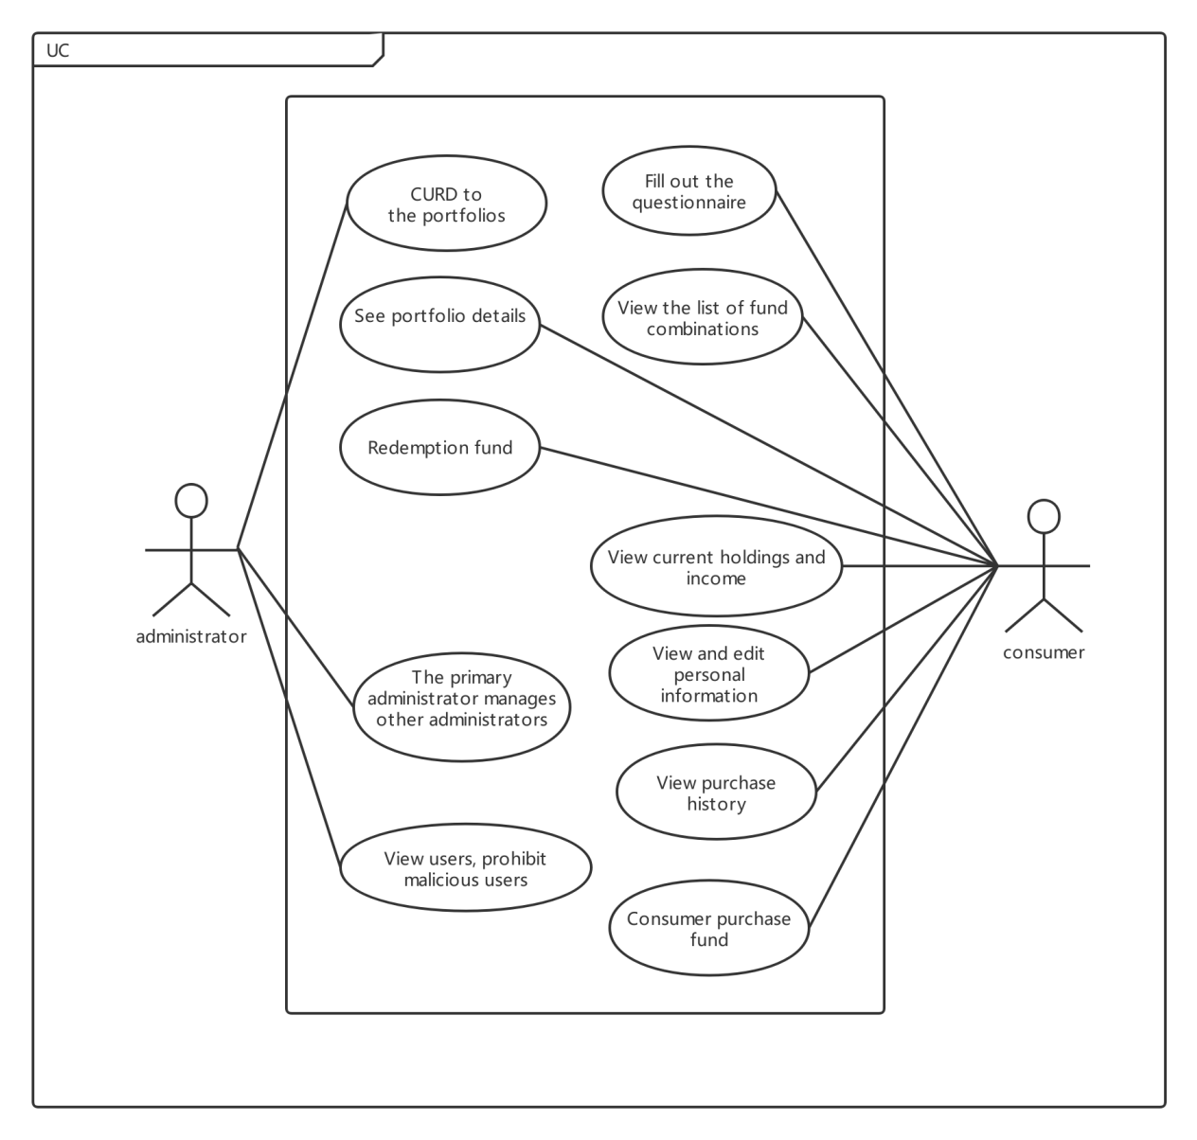

Figure 3.2.1-1 Use Case View

#### 3.2.2 Logical view

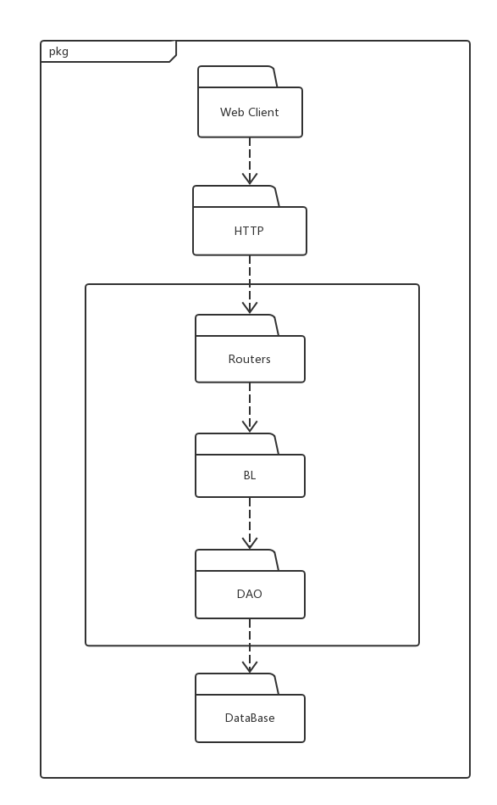 Figure 3.2.2-1 Logical View

#### 3.2.3 Development view

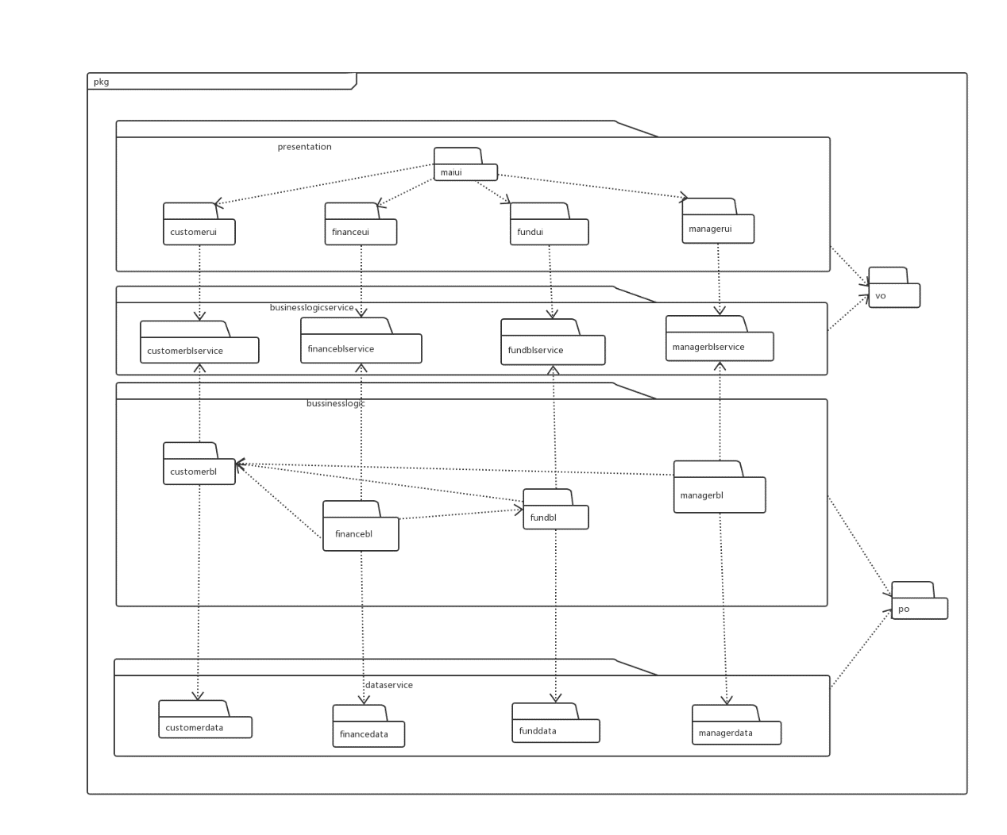Figure 3.2.3-1 Development View

#### 3.2.4 Process view

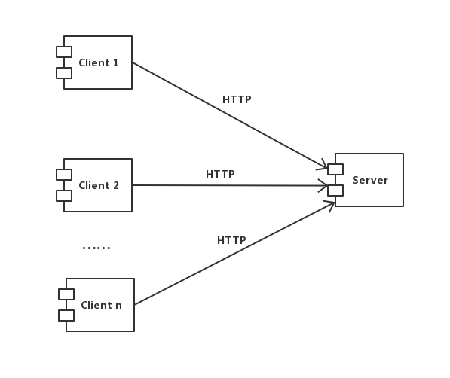Figure 3.2.4-1 Process View

#### 3.2.5 Deployment view

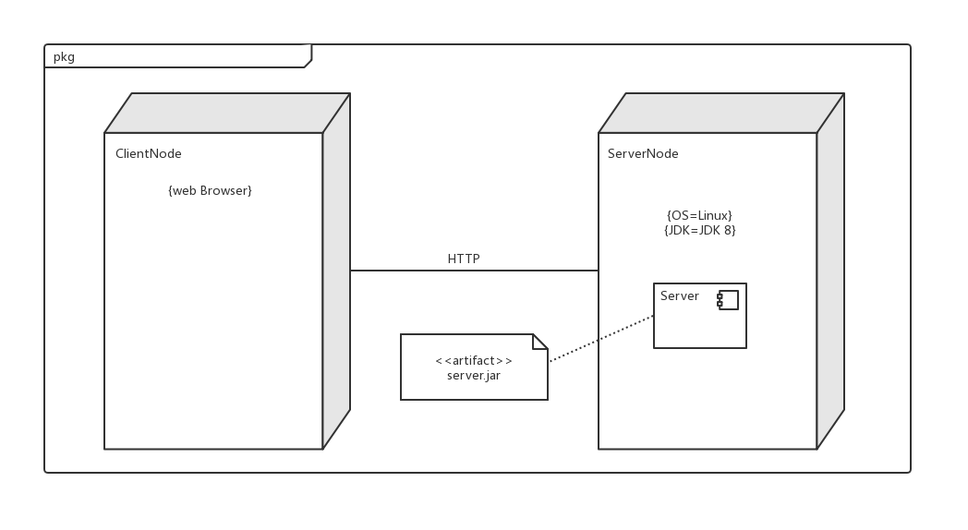

Figure 3.2.5-1 Deployment View